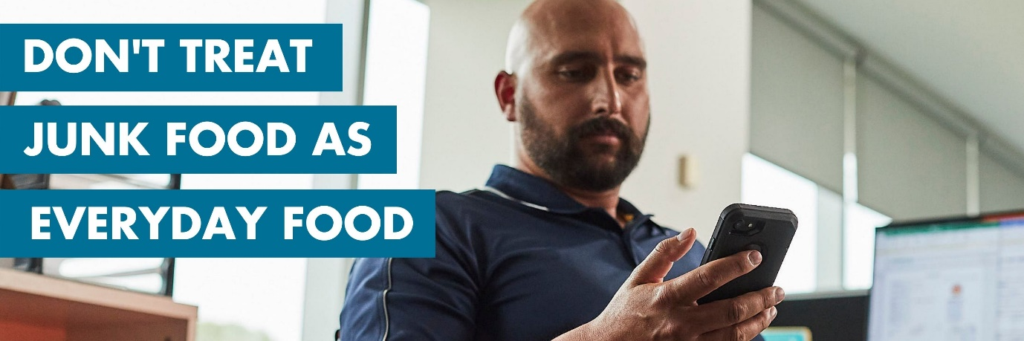
LiveLighter® Menu App, Wave 2 campaign: Social Media Toolkit
Campaign background
There has been a meteoric rise in the number of West Australians ordering food via meal delivery apps over the last few years. The proportion of West Australians using food delivery services has risen from 35% in the first quarter of 2019 to 43% in the first quarter of 2021 (Roy Morgan, 2021).

The proliferation of meal delivery apps has made unhealthy food and drink more available, more accessible, and more heavily promoted than ever before. LiveLighter®’s new Menu App campaign shows common situations in which people consider ordering junk food using a meal delivery app. As they scroll through the menu on their phone the true cost of eating too much junk food is gradually revealed, and the ads conclude with them deciding to prepare a simple, healthy meal at home instead.

Menu App links the regular consumption of junk food to the development of excess body fat and highlights the increased risk of cancer associated with being above a healthy weight. “Don’t treat junk food as everyday food” is the campaign’s call to action.
Cancer Council WA ran the first wave of its new Menu App campaign featuring two executions from 18 March to 15 May 2021 across metro and regional areas on TV, radio, bus shelters, billboards, shopping centres, petrol stations and online. Wave two of the Menu App campaign will be launched on Sunday 4th July and runs until Saturday 11th September. It will feature a new ad focused on the office environment.

Social media assets

We are encouraging all stakeholders to support the launch of Menu App wave two by sharing our social media content through their channels.
When sharing campaign content, please tag LiveLighter® with the relevant handles (see below) and share with the hashtags #LiveLighter and #MenuApp.
 | @LiveLighterCampaign |  | @Live_Lighter |  | @livelightercampaign
 | @livelightercampaign |  | @LiveLighterCampaign
Alternatively, you can share any of our posts from the LiveLighter® Facebook, Twitter, and Instagram accounts. To repost original content via Instagram, you can download an app called ‘Repost’.
Campaign social media assets

All digital tiles, blurbs and banners can be downloaded via this link:
https://livelighter.com.au/Health-Professionals/Menu-app-social-media-assets
Other campaign links
Main campaign page: https://livelighter.com.au/The-Facts/About-Junk-Food

NEW workplace health hub: https://livelighter.com.au/For-Professionals/workplaces

Current campaign page (information for health professionals):
https://livelighter.com.au/Health-Professionals/Current-Campaign

Stakeholder toolkit:
https://livelighter.com.au/assets/health-professionals/toolkit/stakeholder-toolkit-livelighter-menu-app-wave-2.pdf
Campaign key messages
- The regular consumption of junk foods can lead to excess body fat.
- Being above a healthy weight (and having more fat around your middle) is linked to an increased risk of 13 different types of cancers.
- Junk foods are unhealthy foods and drinks which are high in sugar, salt and/or saturated and trans fats. They are typically highly processed and contain only limited nutritional value.
- One action you can take to prevent weight gain is to limit junk food consumption. Don’t treat junk food as everyday food.
- A healthy diet and regular exercise can help lower cancer risk by reducing excess weight gain; these behaviours can also decrease the risk of certain cancers regardless of your current weight.
- It’s easy to make quick, tasty and nutritious meals at home that don’t cost a lot and require minimal planning.
If you have any questions about our social media content or campaign materials, please contact the LiveLighter® social media manager Jasmine Teo:
Jasmine Teo | Communication Coordinator – LiveLighter®
Telephone: 08 6389 7846
Email: jasmine.teo@cancerwa.asn.au

LiveLighter® Menu App, Wave 2 social media content
Social media tiles and blurbs
Social tiles and links  Click here to download all social media assets. | Facebook copy  Copy and paste the blurb directly into a Facebook post.  *Remember to “tag” @LiveLighterCampaign in your post* | Instagram copy  Copy and paste the blurb directly into an Instagram post.  Links don’t work in Instagram posts, so add the link into your bio. Let your followers know by saying something like “To find out more, click the link in our bio”. | Instagram hashtags  Best practice is to post your hashtags as the first comment on your post.  Aim to use a minimum of 15 #hashtags to achieve maximum reach. | Twitter copy  Copy and paste the blurb directly into your Twitter post.  There’s a maximum of 280 characters (including spaces)
Menu App Wave 2 Social media tiles and blurbs
Tile | Facebook copy | Instagram copy | Instagram Hashtags | Twitter copy
Campaign launch tile  Officer worker  30s and 15s, YouTube Ads  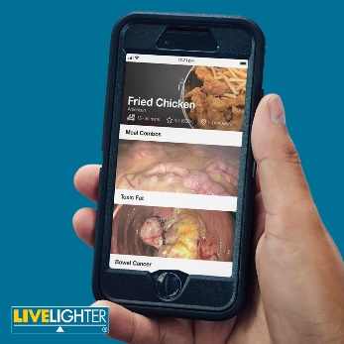  Click here to download the still image tile  Click here to download the animation tile  Video link (15s Ad)  https://bit.ly/3drzgFh  Video link (30s Ad)  https://bit.ly/3AfSnvz  *Choose from either our still or animated versions of this tile | Don’t treat junk food as everyday food. 🤔🍗📲  @LiveLighterCampaign launches the second wave of its ‘Don’t treat junk food as everyday food’ campaign which encourages West Australians to choose a healthier alternative to junk food.  Eating junk food regularly can lead to excess body fat, which increases the risk of 13 different types of cancer and health conditions like heart disease and type 2 diabetes.  To watch the new campaign ad and find out more about the link between junk food and cancer visit: https://bit.ly/3AfSnvz  #MenuApp #Wave2 #LiveLighter | Don’t treat junk food as everyday food. 🤔🍗📲  @livelightercampaign launches the second wave of its ‘Don’t treat junk food as everyday food’ campaign which encourages West Australians to choose a healthier alternative to junk food.  Eating junk food regularly can lead to excess body fat, which increases the risk of 13 different types of cancer and health conditions like heart disease and type 2 diabetes.  To watch the new campaign ad and find out more about the link between junk food and cancer, visit the link in our bio. #MenuApp #Wave2 #LiveLighter  Add link to your bio:  Video link (15s Ad)  https://www.youtube.com/watch?v=9KwOTYNK9HM&list=PLZuJLOaj_w9a-vlWot9qweUSLtjO0uR48&index=3  Video link (30s Ad)  https://www.youtube.com/watch?v=_Brb7sBk-Pc&list=PLZuJLOaj_w9a-vlWot9qweUSLtjO0uR48&index=6 | #LiveLighter #LiveLighterCampaign  #MenuApp #Wave2 #FriedChicken #Fried #Chicken #Officeworker #Office #Worker #New #Creative #DeliveryApp #FoodDelivery #MealDelivery #DinnerDelivery #PizzaDelivery #WhatsReallyOnTheMenu #OnTheMenu #Menu #App #New #NewCampaign #13Cancers #JunkFood #DontTreatJunkFoodAsEverydayFood #ReduceTheJunk #ReduceYourRisk #HealthyAlternatives #Health #Healthy #Nutrition #linkinbio | .@Live_Lighter launches its new campaign encouraging West Australians to choose a healthier alternative to junk food. 🥳  Eating junk food regularly can lead to excess body fat, which increases the risk of 13 different types of cancer.  https://bit.ly/3AfSnvz  #MenuApp #Wave2  Please note*  You need to include the full stop at the start of this blurb, so that your tweet doesn’t go onto your ‘tweets and replies’ page and instead will show up on your page
Tile | Facebook copy | Instagram copy | Instagram Hashtags | Twitter copy
Campaign tile. 1  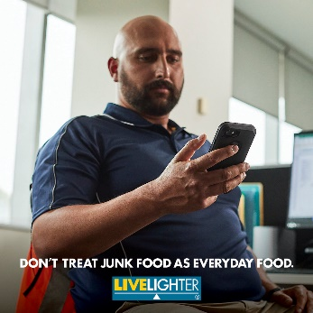  Click here to download the image | Don’t treat junk food as everyday food. 🤔🍗📲  The proliferation of meal delivery apps has made unhealthy food and drinks more accessible than ever before. This is why we are encouraging West Aussies to swap out the greasy takeaway and junk food options, for healthy and easy alternatives you can make at home.  Check out our healthy takeaway alternatives that don’t compromise on taste and ingredients here: https://bit.ly/3d3DN0j @LiveLighterCampaign  #MenuApp #Wave2 #LiveLighter | Don’t treat junk food as everyday food. 🤔🍗📲  The proliferation of meal delivery apps has made unhealthy food and drinks more accessible than ever before. This is why we are encouraging West Aussies to swap out the greasy takeaway and junk food options, for healthy and easy alternatives, which you can make at home.  Check out our healthy takeaway alternatives that don’t compromise on taste and ingredients, by clicking on the link in our bio. @livelightercampaign #MenuApp #Wave2 #LiveLighter  Add link to your bio:  https://livelighter.com.au/assets/resource/booklet/2021-03-09-takeaway.pdf | #LiveLighter #LiveLighterCampaign  #MenuApp #Wave2 #FriedChicken #Fried #Chicken #Officeworker #Office #Worker #New #Creative #DeliveryApp #FoodDelivery #MealDelivery #DinnerDelivery #PizzaDelivery #WhatsReallyOnTheMenu #OnTheMenu #Menu #App #New #NewCampaign #13Cancers #JunkFood #DontTreatJunkFoodAsEverydayFood #ReduceTheJunk #ReduceYourRisk #HealthyAlternatives #Health #Healthy #Nutrition #linkinbio | The proliferation of meal delivery apps has made unhealthy food and drinks more accessible than ever before. @Live_Lighter encourages you to swap out the greasy takeaway and junk food options for healthier alternatives that you can make at home. https://bit.ly/3d3DN0j  #Wave2
Tile | Facebook copy | Instagram copy | Instagram Hashtags | Twitter copy
Campaign tile. 2  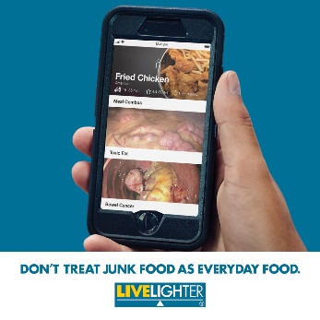  Click here to download the image | Don’t treat junk food as everyday food. 🤔🍗📲  If you're sick of paying top dollar for greasy takeaway packed full of cheap ingredients, then you've come to the right place, we’ve got you covered!  Use our ‘Recipe Finder App’ to find tasty, easy and healthy versions of your fast food favourites that you can make at home. https://bit.ly/2Swfj8V @LiveLighterCampaign  #MenuApp #Wave2 #LiveLighter | Don’t treat junk food as everyday food. 🤔🍗📲  If you're sick of paying top dollar for greasy takeaway packed full of cheap ingredients, then you've come to the right place, we’ve got you covered!  Use our ‘Recipe Finder App’ to find tasty, easy and healthy versions of your fast food favourites that you can make at home. @livelightercampaign #MenuApp #Wave2 #LiveLighter  Add link to your bio:  https://livelighter.com.au/The-Facts/About-Junk-Food | #LiveLighter #LiveLighterCampaign  #MenuApp #Wave2 #FriedChicken #Fried #Chicken #Officeworker #Office #Worker #New #Creative #DeliveryApp #FoodDelivery #MealDelivery #DinnerDelivery #PizzaDelivery #WhatsReallyOnTheMenu #OnTheMenu #Menu #App #New #NewCampaign #13Cancers #JunkFood #DontTreatJunkFoodAsEverydayFood #ReduceTheJunk #ReduceYourRisk #HealthyAlternatives #Health #Healthy #Nutrition #linkinbio | If you're sick of paying top dollar for greasy takeaway packed full of cheap ingredients, then we’ve got you covered!  Use our @Live_Lighter 'Recipe Finder’ to find tasty, easy and healthy versions of your fast food favourites that you can make at home. https://bit.ly/2Swfj8V 📲
Tile | Facebook copy | Instagram copy | Instagram Hashtags | Twitter copy
Campaign tile. 3  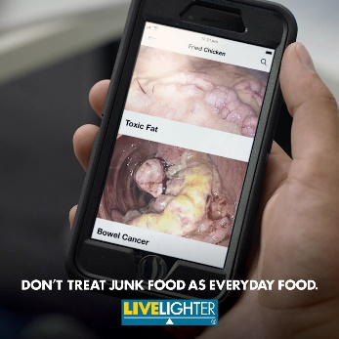  Click here to download the image | Don’t treat junk food as everyday food. 🤔🍔📲  Eating junk food regularly can lead to excess body fat, which increases the risk of 13 different types of cancer.  One way to keep your body running smoothly and reduce your risks, is to swap junk food during your lunch breaks for more nourishing healthier alternatives instead.  For healthy work lunch ideas that don’t compromise on taste visit: https://bit.ly/3hbVzjd #MenuApp #Wave2 #LiveLighter  @LiveLighterCampaign | Don’t treat junk food as everyday food. 🤔🍔📲  Eating junk food regularly can lead to excess body fat, which increases the risk of 13 different types of cancer.  One way to keep your body running smoothly and reduce your risks, is to swap junk food during your lunch breaks for more nourishing healthier alternatives instead.  For healthy work lunch ideas that don’t compromise on taste visit the link in our bio. #MenuApp #Wave2 #LiveLighter  @livelightercampaign  Add link to your bio:  https://livelighter.com.au/news/Work-lunches-that-pull-their-weight | #LiveLighter #LiveLighterCampaign  #MenuApp #Wave2 #FriedChicken #Fried #Chicken #Officeworker #Office #Worker #New #Creative #DeliveryApp #FoodDelivery #MealDelivery #DinnerDelivery #PizzaDelivery #WhatsReallyOnTheMenu #OnTheMenu #Menu #App #New #NewCampaign #13Cancers #JunkFood #DontTreatJunkFoodAsEverydayFood #ReduceTheJunk #ReduceYourRisk #HealthyAlternatives #Health #Healthy #Nutrition #linkinbio | Eating junk food regularly can lead to excess body fat, which increases the risk of 13 different types of cancer.  One way to keep your body running smoothly and reduce your risks is to swap junk food during your lunch breaks for healthier alternatives. https://bit.ly/3hbVzjd  *Tag @Live_Lighter in the photo*
Tile | Facebook copy | Instagram copy | Instagram Hashtags | Twitter copy
Campaign tile. 4  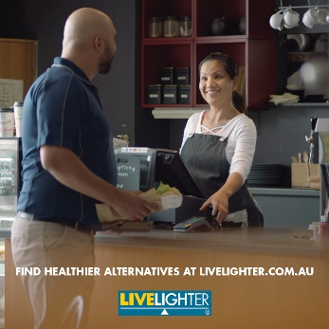  Click here to download the image | Packing your own lunch for work is a great way to save money and help you avoid the temptation of ordering in greasy takeaway when you're under the pump.  It doesn’t get easier than a sandwich, a piece of fruit and a handful of nuts if you’re looking for a healthy, no-nonsense work lunch. 🥪🍏🥜  To build the perfect sandwich, aim to include:  • Grainy or wholemeal bread, roll or wrap  • Plenty of salad or cooked vegies  • A protein-rich food like cheese, shredded chicken, tuna, hummus, roast beef or egg.  For healthy sandwich inspo, check out these healthy #LiveLighter recipes: https://bit.ly/360MqVm @LiveLighterCampaign #MenuApp #Wave2 | Packing your own lunch for work is a great way to save money and help you avoid the temptation of ordering in greasy takeaway when you're under the pump.  It doesn’t get easier than a sandwich, a piece of fruit and a handful of nuts if you’re looking for a healthy, no-nonsense work lunch. 🥪🍏🥜  To build the perfect sandwich, aim to include:  • Grainy or wholemeal bread, roll or wrap  • Plenty of salad or cooked vegies  • A protein-rich food like cheese, shredded chicken, tuna, hummus, roast beef or egg.  For healthy sandwich inspo, check out our healthy #LiveLighter recipes, by clicking the link in our bio. #MenuApp #Wave2 @livelightercampaign  Add link to your bio:  https://livelighter.com.au/recipe/tag/sandwich | #LiveLighter #LiveLighterCampaign  #MenuApp #Wave2 #FriedChicken #Fried #Chicken #Officeworker #Office #Worker #New #Creative #DeliveryApp #FoodDelivery #MealDelivery #DinnerDelivery #PizzaDelivery #WhatsReallyOnTheMenu #OnTheMenu #Menu #App #New #NewCampaign #13Cancers #JunkFood #DontTreatJunkFoodAsEverydayFood #ReduceTheJunk #ReduceYourRisk #HealthyAlternatives #Health #Healthy #Nutrition #linkinbio | Packing your own lunch for work is a great way to save money and help you avoid the temptation of ordering in greasy takeaway when you're under the pump.  For healthy sandwich inspo, check out these recipes: https://bit.ly/360MqVm @Live_Lighter
Social media banners
Promote our Menu App campaign by adding our campaign banners to your page
Menu App Wave 2, Facebook banner (as seen on the LiveLighter® Facebook page)
https://www.facebook.com/LiveLighterCampaign

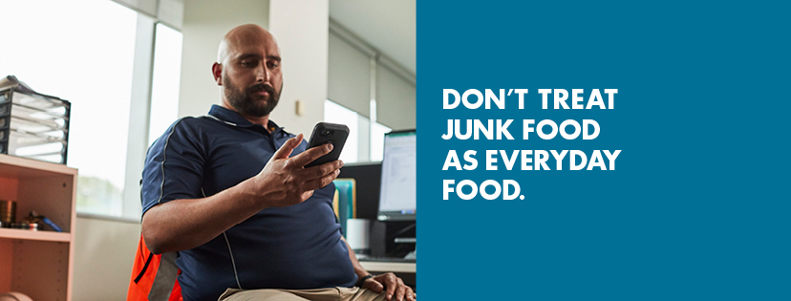
Click here to download the image

Menu App Wave 2, Twitter banner (as seen on the LiveLighter® Twitter page)
https://twitter.com/Live_Lighter

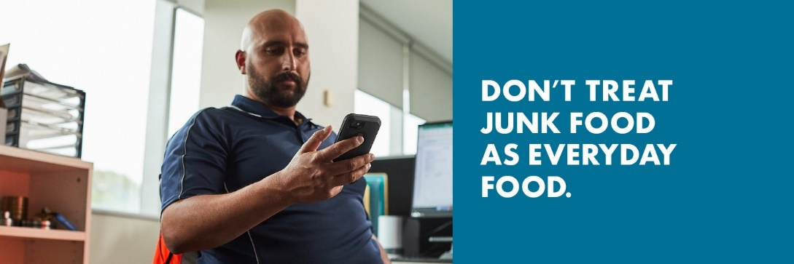
Click here to download the image

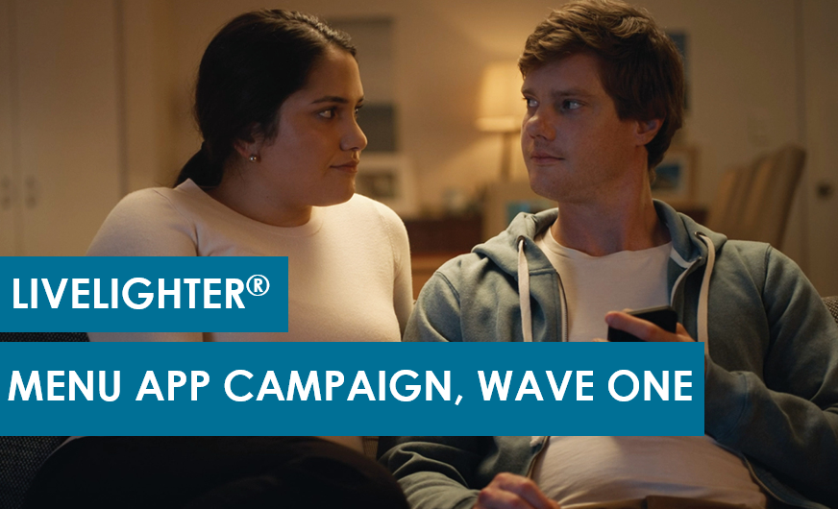
- The following pages are social media materials from Menu App Wave 1
- The below creatives are being used in rotation with the new Office worker creative in Menu App Wave 2

Menu App Wave 1, Social media tiles and blurbs
Social tiles and links  Click here to download all social media assets. | Facebook copy  Copy and paste the blurb directly into a Facebook post.  *Remember to “tag” the @LiveLighterCampaign in your post* | Instagram copy  Copy and paste the blurb directly into an Instagram post.  Links don’t work in Instagram posts, so add the link into your bio. Let your followers know by saying something like “To find out more, click the link in our bio”. | Instagram hashtags  Best practice is to post your hashtags as the first comment on your post.  Aim to use a minimum of 15 #hashtags to achieve maximum reach | Twitter copy  Copy and paste the blurb directly into your Twitter post.  There’s a maximum of 280 characters (including spaces))
Campaign launch tile  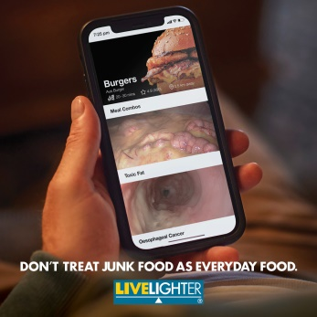  Click here to download the image  *Choose from either our still or animated versions of this tile | What’s really on the menu? 🤔🍟🍕🍔  @LiveLighterCampaign has launched its new campaign, which encourages people to reduce their intake of junk food. The campaign aims to raise awareness of the link between junk food, being above a healthy weight and an increased risk of 13 different cancers.  To watch the new ads and find out more visit: https://bit.ly/3qcxtYg #MenuApp #JunkFood | What’s really on the menu? 🤔🍟🍕🍔  LiveLighter has launched its new campaign, which encourages people to reduce their intake of junk food. The campaign aims to raise awareness of the link between junk food, being above a healthy weight and an increased risk of 13 different cancers.  To watch @livelightercampaign’s new ads and find out more, click the link in our bio. #MenuApp #Junkfood  Add this link to your bio:  https://livelighter.com.au/The-Facts/About-Junk-Food | #LiveLighter #LiveLighterCampaign  #MenuApp #DeliveryApp #FoodDelivery #MealDelivery #DinnerDelivery #PizzaDelivery #WhatsReallyOnTheMenu #OnTheMenu #Menu #App #New #NewCampaign #13Cancers #JunkFood #DontTreatJunkFoodAsEverydayFood #ReduceTheJunk #ReduceYourRisk #HealthyAlternatives #Health #Healthy #Nutrition #linkinbio | @Live_Lighter has launched a new campaign which encourages people to reduce their intake of junk food. The campaign aims to raise awareness of the link between junk food, being above a healthy weight & an increased risk of 13 cancers. https://bit.ly/3qcxtYg  *Tag @Live_Lighter in the photo*
Tile | Facebook copy | Instagram copy | Instagram Hashtags | Twitter copy
LiveLighter Menu App campaign (Couple 30s) - YouTube  Video link:  https://bit.ly/3xGXJy0  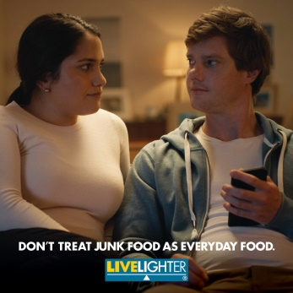  Click here to download the image  *Use the above (still) image for Instagram. | Don’t treat junk food as everyday food. 🤔🍔📲  Eating junk food regularly can lead to excess body fat, which increases the risk of 13 different types of cancer.  One way to keep your body running smoothly is to swap junk food for more nourishing options.  Watch @LiveLighterCampaign’s new campaign video here: https://bit.ly/3xGXJy0 #MenuApp #Junkfood | Don’t treat junk food as everyday food. 🤔🍔📲  Eating junk food regularly can lead to excess body fat, which increases the risk of 13 different types of cancer.  One way to keep your body running smoothly is to swap junk food for more nourishing options.  To watch @livelightercampaign’s new campaign video, click the link in our bio. #MenuApp #Junkfood  Add link to your bio:  https://www.youtube.com/watch?v=H4bLUDn-H4I&list=PLZuJLOaj_w9a-vlWot9qweUSLtjO0uR48&index=4 | #LiveLighter #LiveLighterCampaign #MenuApp #DeliveryApp #FoodDelivery #MealDelivery #DinnerDelivery #PizzaDelivery #WhatsReallyOnTheMenu #OnTheMenu #Menu #App #New #NewCampaign #13Cancers #JunkFood #DontTreatJunkFoodAsEverydayFood #ReduceTheJunk #ReduceYourRisk #HealthyAlternatives #Health #Healthy #Nutrition #linkinbio | Don’t treat junk food as everyday food. Eating junk food regularly can lead to excess body fat, which increases your risk of 13 different cancers.  One way to keep your body running smoothly is to swap junk food for more nourishing options.  https://bit.ly/3xGXJy0  @Live_Lighter
Tile | Facebook copy | Instagram copy | Instagram Hashtags | Twitter copy
LiveLighter Menu App campaign (Mother 30s) - YouTube  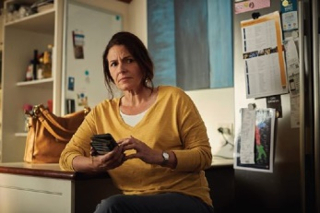  Video link:  https://bit.ly/2TTRMiK  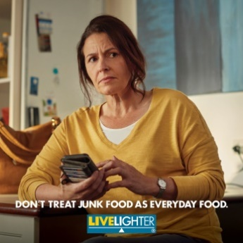  Click here to download the image  *Use the above (still) image for Instagram. | What’s really on the menu? 🤔🍕🥤  Junk foods are loaded with sugar, salt, saturated and trans fat and are low in fruit, vegetables, fibre and wholegrains.  Eating junk foods regularly can make you put on weight. This puts you at risk of 13 types of cancer and health conditions like heart disease, type 2 diabetes and fatty liver disease.  To #LiveLighter and reduce your cancer risk, don’t treat junk food as everyday food.  Find out the facts about junk food here: https://bit.ly/3qcxtYg, or to watch the new campaign video visit: https://bit.ly/2TTRMiK  #MenuApp #Junkfood @LiveLighterCampaign | What’s really on the menu? 🤔🍕🥤  Junk foods are loaded with sugar, salt, saturated and trans fat and are low in fruit, vegetables, fibre and wholegrains.  Eating junk foods regularly can make you put on weight. This puts you at risk of 13 types of cancer and health conditions like heart disease, type 2 diabetes and fatty liver disease.  To #LiveLighter and reduce your cancer risk, don’t treat junk food as everyday food.  To watch @livelightercampaign’s new campaign video and find out more, click the link in our bio. #MenuApp #Junkfood  Add link to your bio:  https://www.youtube.com/watch?v=1-4gfa3WGhs&list=PLZuJLOaj_w9a-vlWot9qweUSLtjO0uR48&index=3 | #LiveLighter #LiveLighterCampaign #MenuApp #DeliveryApp #FoodDelivery #MealDelivery #DinnerDelivery #PizzaDelivery #WhatsReallyOnTheMenu #OnTheMenu #Menu #App #New #NewCampaign #13Cancers #JunkFood #DontTreatJunkFoodAsEverydayFood #ReduceTheJunk #ReduceYourRisk #HealthyAlternatives #Health #Healthy #Nutrition #linkinbio | Eating junk foods regularly can make you put on weight. This puts you at risk of 13 different types of cancer, health conditions like heart disease, type 2 diabetes, and fatty liver disease. Reduce your cancer risk. Don’t treat junk food as everyday food. https://bit.ly/2TTRMiK  *Tag @Live_Lighter in the photo*
Tile | Facebook copy | Instagram copy | Instagram Hashtags | Twitter copy
Campaign tile. 1  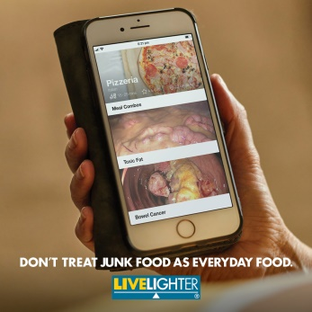  Click here to download the image  *Choose from either our still or animated versions of this tile | What’s really on the menu? 🤔📲🍕  Meal delivery apps have made unhealthy food and drinks more accessible than ever before.  Eating junk food regularly can make you put on weight, which puts you at risk of 13 types of cancer. Don’t treat junk food as everyday food.  Save money and feel good by making healthier versions of your takeaway favourites at home.  To find out the facts about junk food, visit: https://bit.ly/3qcxtYg #MenuApp #Junkfood @LiveLighterCampaign | What’s really on the menu? 🤔📲🍕  Meal delivery apps have made unhealthy food and drinks more accessible than ever before.  Eating junk food regularly can make you put on weight, which puts you at risk of 13 types of cancer. Don’t treat junk food as everyday food.  Save money and feel good by making healthier versions of your takeaway favourites at home.  To find out the facts about junk food, click the link in our bio. @livelightercampaign  #MenuApp #Junkfood  Add link to your bio:  https://livelighter.com.au/The-Facts/About-Junk-Food | #LiveLighter #LiveLighterCampaign #MenuApp #DeliveryApp #FoodDelivery #MealDelivery #DinnerDelivery #PizzaDelivery #WhatsReallyOnTheMenu #OnTheMenu #Menu #App #New #NewCampaign #13Cancers #JunkFood #DontTreatJunkFoodAsEverydayFood #ReduceTheJunk #ReduceYourRisk #HealthyAlternatives #Health #Healthy #Nutrition #linkinbio | Meal delivery apps have made unhealthy food and drinks more accessible than ever before.  Save money and feel good by making healthier versions of your takeaway favourites at home. https://bit.ly/3qcxtYg  @Live_Lighter
Tile | Facebook copy | Instagram copy | Instagram Hashtags | Twitter copy
Campaign tile. 2  Click here to download the image | What’s really on the menu? 😮📲🍔  Alarmingly, Australian adults are getting more than a third of their daily energy from junk food.  Eating too many junk foods is linked to excess weight gain, which increases the risk of 13 types of cancer.  Don’t treat junk food as everyday food. Reduce the junk, reduce your risk.  Watch @LiveLighterCampaign’s new campaign video here: https://bit.ly/3hnaG9D  #MenuApp #Junkfood | What’s really on the menu? 😮📲🍔  Alarmingly, Australian adults are getting more than a third of their daily energy from junk food.  Eating too many junk foods is linked to excess weight gain, which increases the risk of 13 types of cancer.  Don’t treat junk food as everyday food. Reduce the junk, reduce your risk.  To watch @livelightercampaign’s new campaign video, click the link in our bio. #MenuApp #Junkfood  Add link to your bio:  LiveLighter Menu App campaign (Couple 30s) - YouTube | #LiveLighter #LiveLighterCampaign #MenuApp #DeliveryApp #FoodDelivery #MealDelivery #DinnerDelivery #PizzaDelivery #WhatsReallyOnTheMenu #OnTheMenu #Menu #App #New #NewCampaign #13Cancers #JunkFood #DontTreatJunkFoodAsEverydayFood #ReduceTheJunk #ReduceYourRisk #HealthyAlternatives #Health #Healthy #Nutrition #linkinbio | Australian adults get more than a third of their daily energy from junk food.  Eating too much junk food is linked to excess weight gain, which increases the risk of 13 types of cancer.  Reduce the junk, reduce your risk  Find out more: https://bit.ly/3hnaG9D  @Live_Lighter
Tile | Facebook copy | Instagram copy | Instagram Hashtags | Twitter copy
Campaign tile. 3  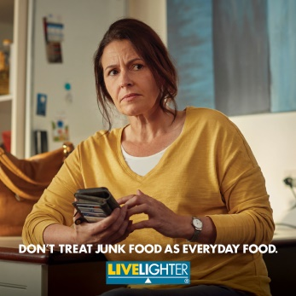  Click here to download the image | Takeaway used to be an occasional treat but these days, Australians are eating it more and more often. 🍔🍟🍕📈  These foods cost top dollar, but are often loaded with cheap ingredients like sugar, salt and saturated and trans fats. They also tend to come in much bigger servings than we need.  Eating fast food regularly can make you put on weight. This puts you at risk of 13 different types of cancer and health conditions like heart disease and type 2 diabetes.  For quick, easy and tasty versions of your fast food favourites that you can make at home check out @LiveLighterCampaign’s new campaign: https://bit.ly/3qcxtYg  #MenuApp | Takeaway used to be an occasional treat but these days, Australians are eating it more and more often. 🍔🍟🍕📈  These foods cost top dollar, but are often loaded with cheap ingredients like sugar, salt and saturated and trans fats. They also tend to come in much bigger servings than we need.  Eating fast food regularly can make you put on weight. This puts you at risk of 13 different types of cancer and health conditions like heart disease and type 2 diabetes.  For quick, easy and tasty versions of your fast food favourites that you can make at home check out @livelightercampaign’s new campaign, by clicking the link in our bio. #MenuApp  Add link to your bio:  https://livelighter.com.au/The-Facts/About-Junk-Food | #LiveLighter #LiveLighterCampaign #MenuApp #DeliveryApp #FoodDelivery #MealDelivery #DinnerDelivery #PizzaDelivery #WhatsReallyOnTheMenu #OnTheMenu #Menu #App #New #NewCampaign #13Cancers #JunkFood #DontTreatJunkFoodAsEverydayFood #ReduceTheJunk #ReduceYourRisk #HealthyAlternatives #Health #Healthy #Nutrition #linkinbio | Takeaway foods may cost top dollar, but are often loaded with cheap ingredients like sugar, salt and saturated and trans fats.  For quick, easy and tasty versions of your fast-food favourites that you can make at home check out @Live_Lighter’s new campaign: https://bit.ly/3qcxtYg  *Tag @Live_Lighter in the photo*
Social media banners
Promote our Menu App campaign by adding our campaign banners to your page
Menu App Facebook banner
https://www.facebook.com/LiveLighterCampaign

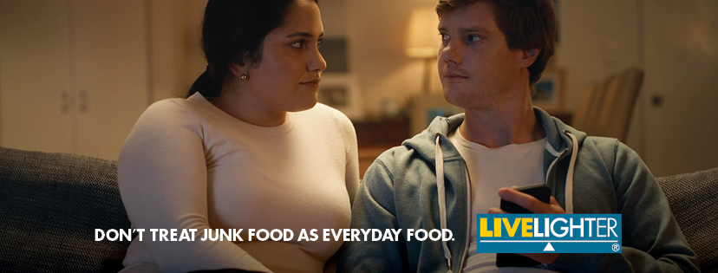
Click here to download the image

Menu App Twitter banner
https://twitter.com/Live_Lighter

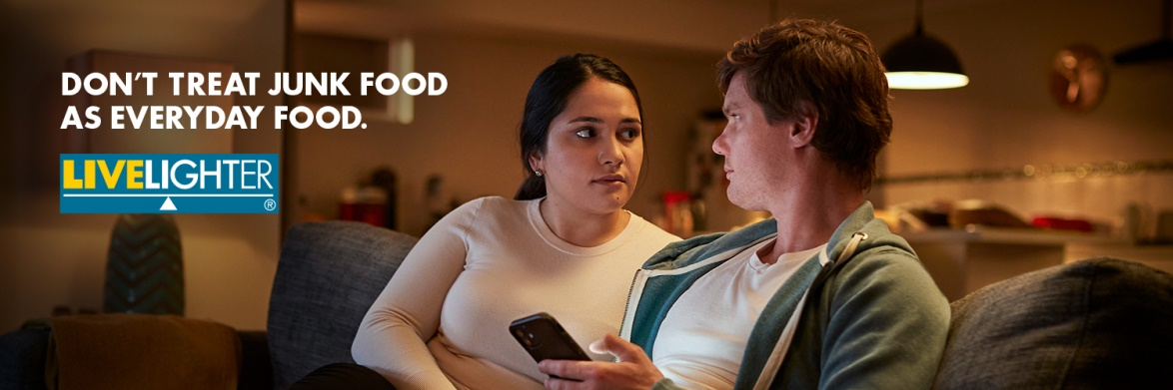
Click here to download the image
Newsletter inserts
Click here to download the image Click here to download the image
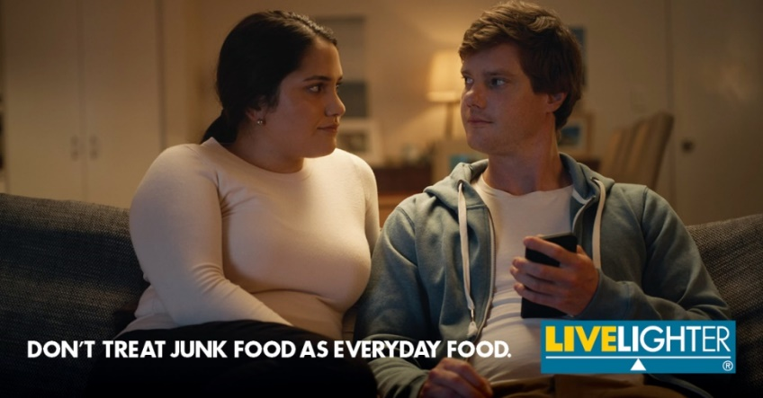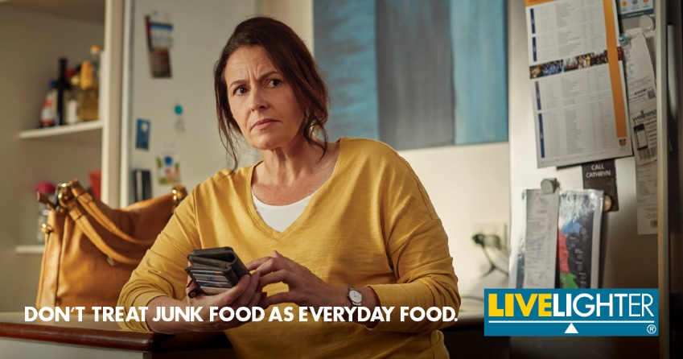

What’s really on the menu?

LiveLighter has launched its new campaign, which encourages people to find alternatives to junk food. It’s also raising awareness of the link between junk food, being above a healthy weight and the increased risk of 13 different cancers.

To watch the new videos, or to find out more visit: https://livelighter.com.au/The-Facts/About-Junk-Food

